### Setup and installation

Steps to install dependencies and libraries as below:-

1. Download the zip file from the below link

<https://www.anaconda.com/products/individual>

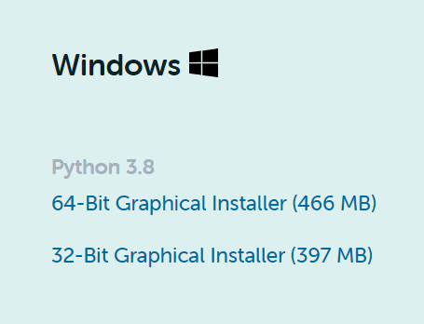

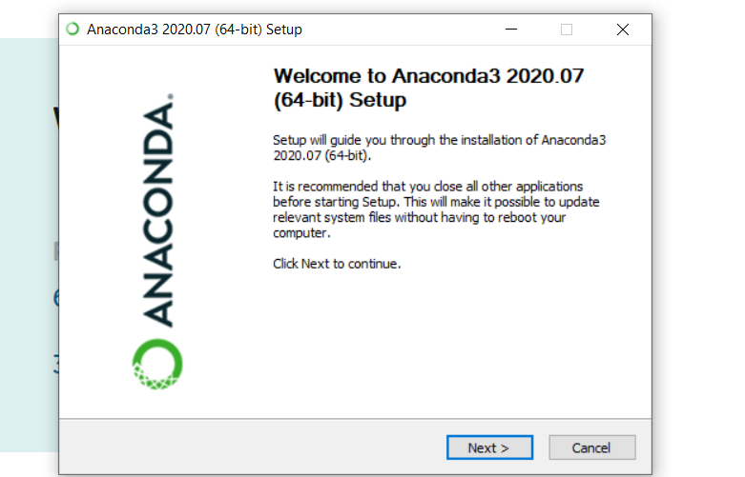

**P2. Install below mentioned library with pip command only in anaconda command prompt**

pip install gunicorn flask

pip install numpy

pip install pytesseract

pip install opencv-python

pip install torch==1.3.1+cpu torchvision==0.4.2+cpu -f <https://download.pytorch.org/whl/torch_stable.html>

pip install langdetect

pip install laserembeddings

pip install laserembeddings[en,eu,de,fr]

pip install flask

pip install flask_restful

pip install requests

pip install gtts

pip install boto3

python -m laserembeddings download-models

pip install wheel

to run the python file

python file.py

**3.Import the file and run in Spyder**